**Sadfhghjkl;’loiuytreszxcvbnm**

**DEPARTMENT OF ELECTRONICS AND TELECOMMUNICATION ENGINEERING**

**University of Mumbai**

**Academic Year-2018-19.**

**Mini Project Report**

**on**

**Laser Light Detector**

Submitted in partial fulfillment of the requirements of

Subject **Electronic Devices and Circuits - Ⅱ**

**Second Year of Engineering**

**In**

**Electronics and Telecommunication Engineering**

**BY**

**Mr.Aditya Narayan (Roll No. 422 )**

**Mr.Lekhraj Kasar (Roll No. 429)**

**Mr.Hemant Koyande (Roll No. 431 )**

**Miss. Harshita Kulal (Roll No. 432 )**

**Under the Guidance of**

**Prof. J .R. Mahajan**

**(Permanently Affiliated to University of Mumbai)**

**Department of Electronics and Telecommunication Engineering**

**(2019-2020)**

**CERTIFICATE**

This is to certify that the project entitled “Laser Light Detector” is a bonafide work of Mr.Aditya Narayan , Mr.Lekhraj Kasar , Mr.Hemant Koyande , Ms.Harshita Kulal under the supervision of Prof. J.R MAHAJAN submitted to the university of Mumbai in partial fulfillment of the requirement for the subject of “ELECTRONICS DEVICES AND CIRCUITS” of engineering in Electronics and telecommunication engineering.

PROF. J.R MAHAJAN DR. S.D.DESHMUKH

SUBJECT IN CHARGE HEAD OF DEPARTMENT

|  |  |  |
| --- | --- | --- |
| **SR.NO** | **TITLE** | **PAGE NO.** |
| **1.** | **ABSTRACT** | **03** |
| **2.** | **INTRODUCTION** | **04** |
| **3.** | **COMPONENTS USED** | **05** |
| **4.** | **CIRCUIT DIAGRAM** | **10** |
| **5.** | **WORKING OF CIRCUIT** | **11** |
| **6.** | **PCB DESIGNING** | **12** |
| **7.** | **CONCLUSION** | **14** |
| **8.** | **FUTURE SCOPE** | **14** |
| **9.** | **REFERENCES** | **14** |

**ABSTRACT**

Laser based Security System is a type of security and alarm system that uses laser light and a light sensor. A security system protects our homes, offices, banks, lockers etc. from intrusion and unauthorised access. There are different types of security systems available and laser based security system is an important and efficient type.

A Laser security system can acts as a standalone system, which makes some sound or noise when it detects any irregular activity, or can be part of a much bigger security and home automation system, which can send messages, call the owner etc.

**INTRODUCTION**

* Security is a most important factor today. Technology develops day by day in the world. The crime gang also improves their technology to perform their operation. So technology of security should be modern with time to protect the crime works. We decide to make a security project as our project. In this project we have used laser light to cover a large area.
* We know laser light goes through long distance without scattering effect. It’s also visible only at source and incident point, otherwise invisible. These two properties help us to build up a modern security system, which may name as “laser security”.
* When any person or object crossover the laser line the security alarm will ringing and also the focus light will “on” to focus the entrance of unauthorized person. Presented here is a security system that uses an inexpensive laser torch which is usually available with a key ring.
* The advantage of this security lock is that you can use any laser torch or pointer that is easily available in toy shops. It employs minimal input keys and yet is very secure. It can be used as a door lock, briefcase lock or any other application related to an electronic locking system.

**Components Used**

1. BC 547B
2. Resistor 150kΩ
3. Light Dependent Resistor (LDR)
4. Light Emitting Diode (LED)
5. Buzzer
6. Battery 9V

**COMPONENTS USED**

* BC547

**BC547**is an NPN Bipolar Junction Transistor. Mostly it is used for the switching purpose as well as for amplification purposes. Similar to the other transistors BC547 is also used for the amplification of current. The smaller amount of current at the base is used to control the larger amount of currents at collector and emitter as well. Its basic applications are switching and amplification. The transistor, BC 547 is shown in the figure below.

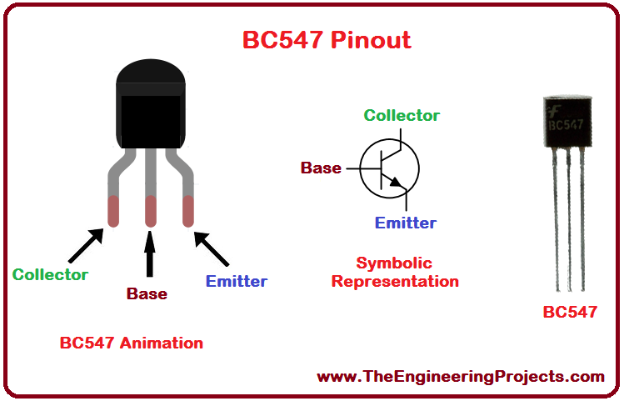

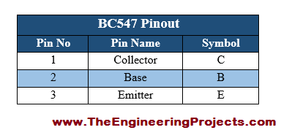

1 . Resistor

A **resistor** is a passive two-terminal electrical component that implements electrical resistance as a circuit element. In electronic circuits, **resistors** are used to reduce current flow, adjust signal levels, to divide voltages, bias active elements, and terminate transmission lines, among other uses.

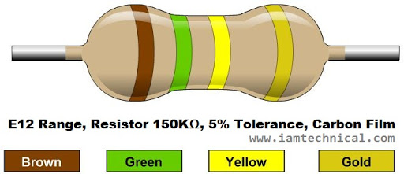

**Resistor Used**

1. Resistor ……. 150 kΩ (**Brown, Green, Yellow**, **Gold**)

**2 . Light emitting Diode (LDR)**

A **Light Dependent Resistor** (also known as a photoresistor or LDR) is a device whose [resistivity](https://www.electrical4u.com/electrical-resistance-and-laws-of-resistance/) is a function of the incident electromagnetic radiation. Hence, they are light-sensitive devices. They are also called as photoconductors, photoconductive cells or simply photocells.

They are made up of [semiconductor](https://www.electrical4u.com/theory-of-semiconductor/) materials that have high resistance. There are many different symbols used to indicate a photoresistor or LDR, one of the most commonly used symbol is shown in the figure below. The arrow indicates light falling on it.

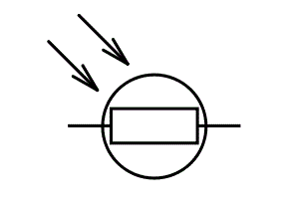Symbol of a Photoresistor (or LDR)

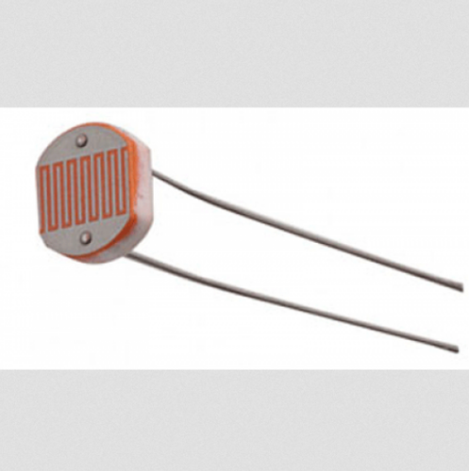

**3 . LED**

A **light-emitting diode** (**LED**) is a [semiconductor](https://en.wikipedia.org/wiki/Semiconductor) [light source](https://en.wikipedia.org/wiki/Light_source) that emits light when [current](https://en.wikipedia.org/wiki/Electric_current) flows through it. [Electrons](https://en.wikipedia.org/wiki/Electron) in the semiconductor recombine with [electron holes](https://en.wikipedia.org/wiki/Electron_hole), releasing energy in the form of [photons](https://en.wikipedia.org/wiki/Photon). The color of the light (corresponding to the energy of the photons) is determined by the energy required for electrons to cross the [band gap](https://en.wikipedia.org/wiki/Band_gap) of the semiconductor.[[5]](https://en.wikipedia.org/wiki/Light-emitting_diode#cite_note-5) White light is obtained by using multiple semiconductors or a layer of light-emitting phosphor on the semiconductor device.

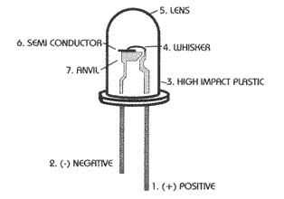 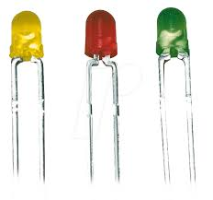

**4. BUZZER**

A **buzzer** or beeper is an audio signalling device, which may be mechanical, electromechanical, or piezoelectric (piezo for short). Typical uses of **buzzers** and beepers include alarm devices, timers, and confirmation of user input such as a mouse click or keystroke.

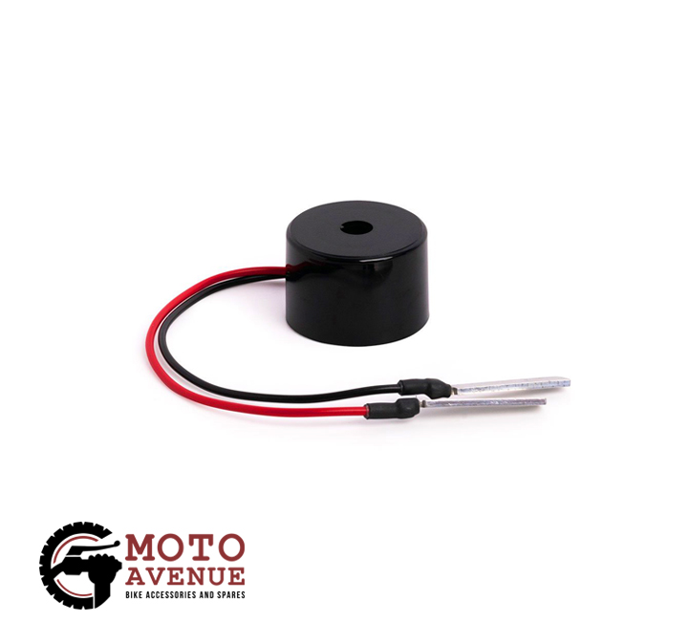

**5 . BATTERY**

A **battery** is a device consisting of one or more [electrochemical cells](https://en.wikipedia.org/wiki/Electrochemical_cell) with external connections provided to power electrical devices such as [flashlights](https://en.wikipedia.org/wiki/Flashlight), [mobile phones](https://en.wikipedia.org/wiki/Mobile_phone), and [electric cars](https://en.wikipedia.org/wiki/Electric_car).[[1]](https://en.wikipedia.org/wiki/Electric_battery#cite_note-1) When a battery is supplying [electric power](https://en.wikipedia.org/wiki/Electric_power), its positive terminal is the [cathode](https://en.wikipedia.org/wiki/Cathode) and its negative terminal is the [anode](https://en.wikipedia.org/wiki/Anode).[[2]](https://en.wikipedia.org/wiki/Electric_battery#cite_note-Pauling1988-2) The terminal marked negative is the source of electrons that will flow through an external electric circuit to the positive terminal. When a battery is connected to an external electric load, a [redox](https://en.wikipedia.org/wiki/Redox) reaction converts high-energy reactants to lower-energy products, and the [free-energy](https://en.wikipedia.org/wiki/Gibbs_free_energy) difference is delivered to the external circuit as electrical energy.

Here the battery that we are using is 5V. 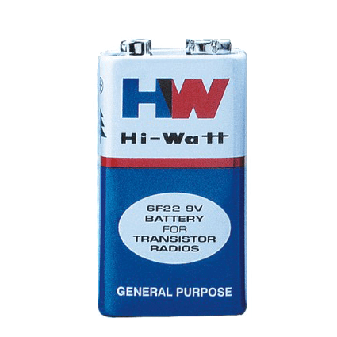

**Circuit Diagram**

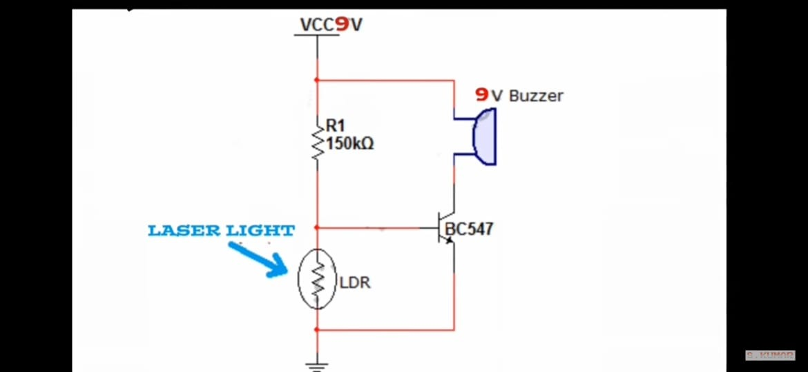

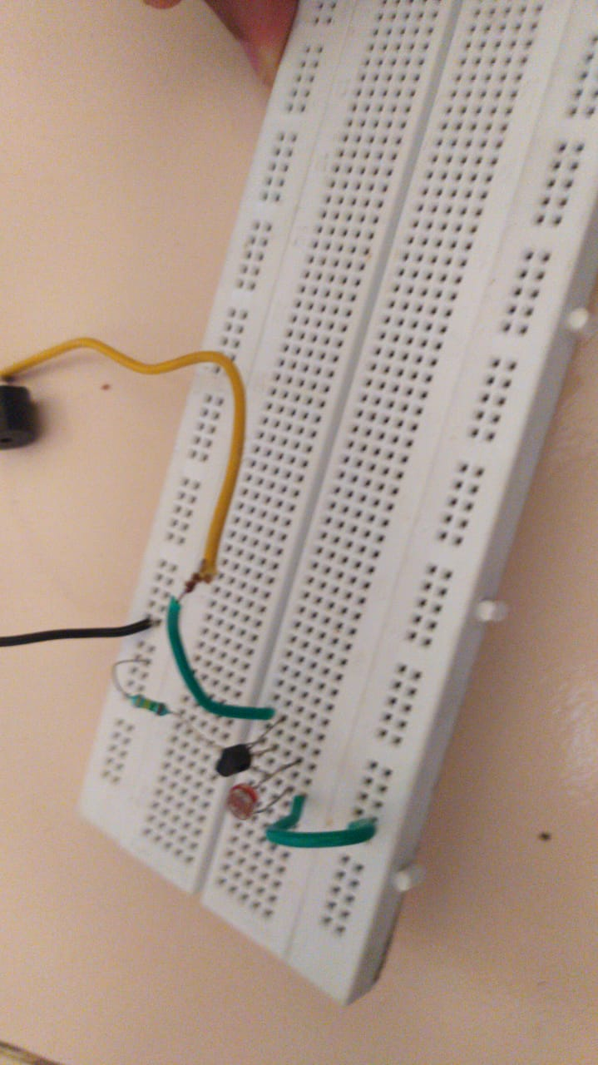

**WORKING OF CIRCUIT**

The basic sensing component of a modern laser security system is an infrared motion detector. An infrared motion detector works by using beams of infrared light to detect changes in heat. When a person moves into the beam of light, the sensor is alerted by the body heat given off by the individual. If infrared sensors are placed strategically, the beams of light will make it impossible for an intruder to come into the area without the sensor being alerted. The sensor, which is connected to the basic alarm unit through a wireless connection, then triggers the basic unit to alert the monitoring service through which the customer purchased the security plan. The monitoring service will contact the home and, if no response is received, will contact the police. In most models, the basic unit also sounds a loud alarm.

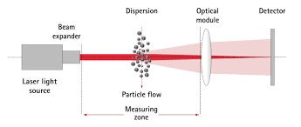

**Pcb Designing**



**CONCLUSION**

Laser security system a person moves infront of the motion sensor, that person’s body heat triggers the system’s alarm. And the alarm signals the security monitoring company and local law enforcement. The basic alarm unit will also sound a loud alarm.

The main objectives of laser light detector are:

## A car might have a few beams of lasers to monitor any upcoming collisions.

1. In 3D scanning. Yes. Lasers will be used in making a 3D map of the surrounding world.
2. Lasers to cut materials. Assemble and control robots.

**FUTURE SCOPE**

**Laser** light **can** be controlled very precisely, so scientists **can use** it to perform extremely fine operations. For example, **lasers could** be **used** to cut out parts to make molecule-size motors. ... One possible **future use** of **lasers** is to supply energy to spacecraft.

**REFERENCES**

[www.wikipedia.com](http://www.wikipedia.com)

[www.encyclopedia.com](http://www.encyclopedia.com)